
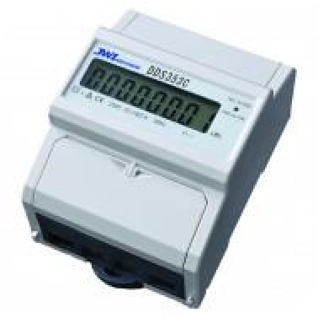
DDS353C 100A Direct Connected MID Certified kWh Meter

MID B+D Certified
Single Phase 100A Direct connected Rated voltage: 220V/230V
DIN Rail Mounted
Impulse Constant 1000imp/kWh LCD 5+2 = 99999.99kWh Display Self-Supplied
Cost Effective
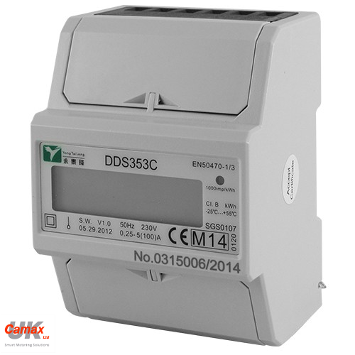

▪
▪
▪
▪
▪
▪
▪
▪



DDS353C 100A Single Phase kWh Meter

The DDS353C is a new generation modern design kWh meter that will measure and display Active Energy (kWh). It is housed in a compact DIN rail mounted module case and has been MID B+D certified.

Technical Specification
Voltage:
Current:
Accuracy Class:
Standard:
Frequency:
Impulse Constant:
Display:
Power Consumption:
Temperature Range:
Pulse Width:
Max Terminal Wire:
230V ± 20%
(5)100A B
EN50470-1 / EN50470-3 50Hz ±10%
Red LED 1000imp/kWh LCD 5+2= 99999.99kW
≤1W
-25⁰C……+55⁰C 52mS
19mm₂

DDS353C 100A Direct Connected MID Certified kWh Meter

Dimensions:

76mm
65mm
100mm
45mm
36 mm

+

Wiring Diagram:



