

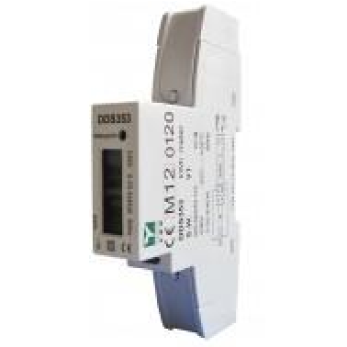
DDS353 45A Direct Connected MID Certified kWh Meter

MID B+D Certified
Single Phase 45A Direct connected Rated voltage: 220V/230V
DIN Rail Mounted
Impulse Constant 1000imp/kWh LCD 5+2 = 99999.99kWh Display Self-Supplied
Cost Effective

▪
▪
▪
▪
▪
▪
▪
▪



DDS353 45A Single Phase kWh Meter

The DDS353 is a new generation modern design kWh meter that will measure and display Active Energy (kWh). It is housed in a compact DIN rail mounted module case and has been MID B+D certified.

Technical Specification
Voltage:
Current:
Accuracy Class:
Standard:
Frequency:
Impulse Constant:
Display:
Power Consumption:
Temperature Range:
Pulse Width:
Max Terminal Wire:
230V ± 20%
(5)45A B
EN50470-1 / EN50470-3 50Hz ±10%
Red LED 1000imp/kWh LCD 5+2= 99999.99kW
≤8VA ≤0.4W
-25⁰C……+55⁰C 80mS
12mm₂
DDS353 45A Direct Connected MID Certified kWh Meter

Dimensions:

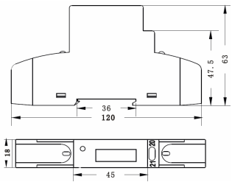

Wiring Diagram:

