MECHANICAL INSTALLATION
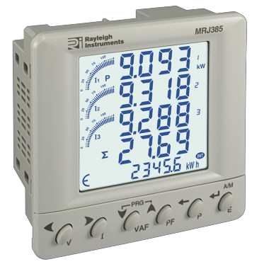For installing the meter
SERIAL COMMUNICATION
Interface Standard and protocol | RS485 & Modbus RTU
Communication address | 1 to 255
Transmission Mode | Half duplex
Data types | Float and Integer
Transmission distance | 500 Meter maximum
Transmission speed | 300, 600, 1200, 2400, 4800  9600 19200 (bps)
Parity | None, Odd, Even
Stop bits | 1 or 2
Response time | 100mS

RESOLUTION FOR CT RATING
CT Rating | KWh
160A | 0.1K
250A | 0.1K
400A | 0.1K
800A | 1K

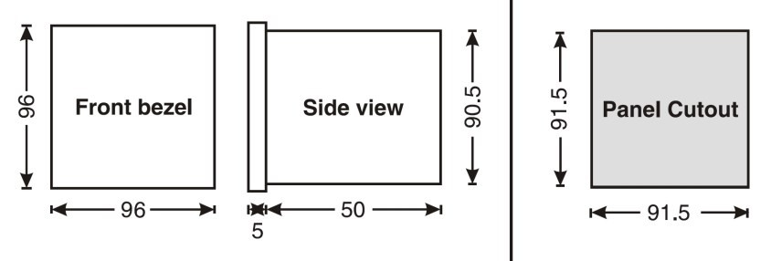1. Prepare the panel cut out with the dimensions as shown below.
Meter Outline
Dimensions (In mm)
Panel Cut-out
Dimensions (In mm)

SAFETY PRECAUTIONS

DISPLAY
SPECIFICATIONS
Liquid crystal display with backlight
4 line, 4 digits per line to show electrical Parameters 5th line, 8 digits to show energy
Bar graph for current indication as a % of CT rating
LCD INDICATIONS
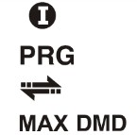
- Integration of energy
- Unit is in configuration menu
- Communication in progress
- Maximum & Minimum Demand of Power
WIRING INPUT
3.Ø - 4 wire, 1.Ø - 2 wire
RATED INPUT VOLTAGE
100 TO 240Vac (L-N); 173-415Vac (L-L)
FREQUENCY RANGE
45-65Hz
CT PRIMARY
5A to 10000A (Programmable for any value)
CT SECONDARY
330mV
PT PRIMARY
100 to 500KVac (Programmable for any value)
PT SECONDARY
100 to 500Vac (Programmable for any value)
DISPLAY UPDATE TIME
1 Second for parameters
DISPLAY SCROLLING
Automatic / Manual
AUXILIARY
Self supplied
TEMPERATURE
Operating : 0 to 50°C
Storage : -20 to 75°C
HUMIDITY
85% non-condensing
MOUNTING
Panel mounting, front panel to IP65
WEIGHT
230gms
OUTPUT
Pulsed Output : Voltage range External 24VDC max
Current capacity : 100mA
INSTALATION CATEGORY
Category III

ACCURACY
Measurement | Accuracy
Voltage V L-N | ±0.5% of Full Scale
Voltage V L-L | ±0.5% of Full Scale
Current | ±0.5% of Full Scale
Frequency | ±0.1% of Full Scale For L-N Voltage >20V For L-L Voltage >35V
Active Power | Class 0.5
Reactive Power | Class 1.0
Apparent Power | Class 1.0
Power Factor | ±0.1%
Active Energy | Class 1.0
Reactive Energy | Class 2.0
Apparent Energy | Class 2.0
MAX / Min Active Power | 1%
MAX / MIN Reactive Power | 1%
MAX Apparent Power | 1%

RESOLUTION
PT Ratio x CT Ratio | KWh / KVAh / KVArh | Pulse
<15 | 0.01K | 0.01K
<150 | 0.1K | 0.1K
<1500 | 1K | 1K
<15000 | 0.01M | 0.01M
<150000 | 0.1M | 0.1M
≥1500000 | 1M | 1M

NOTE: 1) For Voltage, Current, Power, resolution is automatically adjusted.
2) For Power Factor resolution is 0.001
3) Blink every 5 seconds, if a load is connected to at least 1 of the 3 phases
All safety related codifications, symbols and instructions that appear in this operation manual or on the equipment must be strictly followed to ensure the safety of the operating personnel as well as the instrument.
If the equipment is not used in the manner specified by the manufacturer it might impair the protection provided by the equipment.
CAUTION
Read the instructions prior to installation and operation of the unit.

CAUTION
Risk of electrical shock
WIRING GUIDELINES

CAUTION
INSTALLATION GUIDELINES
- This equipment, being of a built-in-type, normally becomes a part of a main control panel and in case the terminals do not remain accessible to the end user after installation and internal wire.
- Conductors must not come into contact with the internal circuitry of the equipment or it may lead to a safety hazard that may in turn endanger life or cause electrical shock to the operator.
- Protection & disconnection means must be installed between power source and supply terminals to facilitate power ‘ON’ or ‘OFF’ function & must be installed in a con- venient position normally accessible to the operator.

CAUTION
The equipment shall not be installed in environmental conditions other that those mentioned in this manual

- Push the meter into the panel cut-out. Secure the meter in its place by fitting the clamp from the rear side. Fit clamps on both sides in diagonally opposite location for optimum fitting.
- For proper sealing, tighten the screws evenly with required torque.
- Recommended conductor cross section = 1.5mm2. Screw clamps tightening torque = 0.1N-m
CAUTION
The equipment in its installed state must not co in close proximity to any heating sources, caustic vapour, oil, steam or other unwanted process by-products.

EMC Guidelines

- Use input power cable with shortest connections.
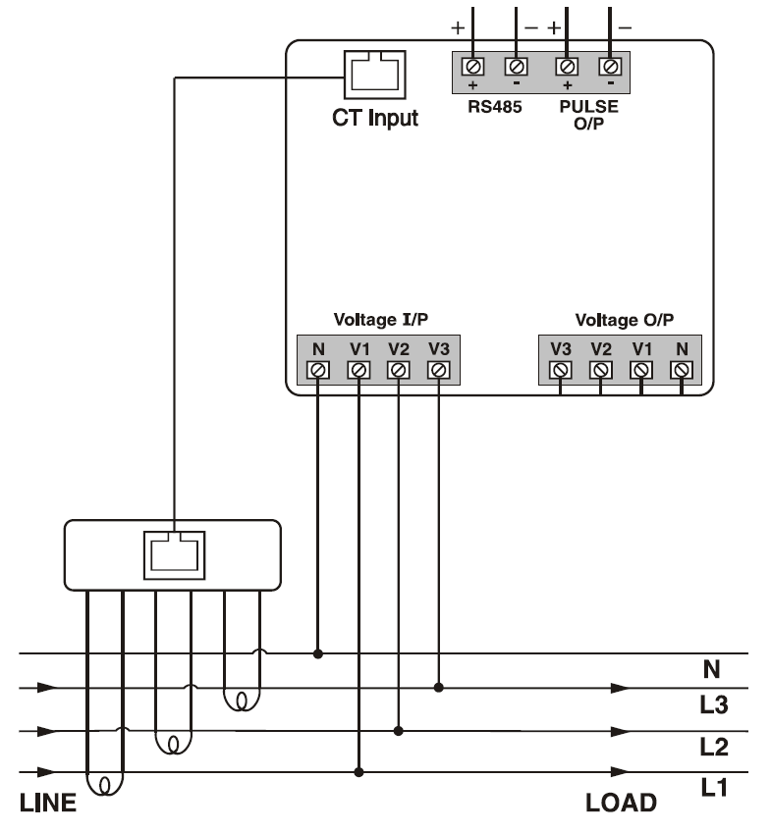
- Layout of connecting cables shall be away from any internal EMI source.
TERMINAL CONNECTIONS

ONLINE PAGE DESCRIPTION
There are 6 dedicated keys labelled as V, I, VAF, PF, P, E. Use these
KEY PRESS | ONLINE PAGE DESCRIPTION
Press “E” | The first screen. Displays import active energy of first phase.  The second screen. Displays import active energy of second phase.  The third screen. Displays import active energy of third phase.  The fourth screen. Displays export active energy of first phase.  The fifth screen. Displays export active energy of second phase.  The sixth screen. Displays export active energy of third phase.  The seventh screen. Displays total import active energy of three phase.  The eighth screen. Displays total export active energy of three phase.  The ninth screen. Displays total net active energy of three phase.  The tenth screen. Displays import reactive energy of first phase.  The eleventh screen. Displays import reactive energy of second phase.  The twelfth screen. Displays import reactive energy of third phase.  The thirteenth screen. Displays export reactive energy of first phase.  The fourteenth screen. Displays export reactive energy of second phase.  The fifteenth screen. Displays export reactive energy of third phase.  The sixteenth screen. Displays total import reactive energy of three phase.  The seventeenth screen. Displays total export reactive energy of three phase.  The eighteenth screen. Displays total net reactive energy of three phase.  The nineteenth screen. Displays apparent energy of first phase.  The twentieth screen. Displays apparent energy of second phase.  The twenty first screen. Displays apparent energy of third phase.  The twenty second screen. Displays total net apparent energy of three phase.  The twenty third screen. Displays hours run.
Note : For 1.Ø - 2W network, all pages will be the as 3.Ø - 4W only selected phase parameters will be displayed.

Config. Page | Function | Rangeor Selection | Factory Setting
16.08 | Page Sequence 8 | Page8of21 | 8
16.09 | Page Sequence 9 | Page9of21 | 9
16.10 | Page Sequence 10 | Page10of21 | 10
16.11 | Page Sequence 11 | Page11of21 | 11
16.12 | Page Sequence 12 | Page12of21 | 12
16.13 | Page Sequence 13 | Page13of21 | 13
16.14 | Page Sequence 14 | Page14of21 | 14
16.15 | Page Sequence 15 | Page15of21 | 15
16.16 | Page Sequence 16 | Page16of21 | 16
16.17 | Page Sequence 17 | Page17of21 | 17
16.18 | Page Sequence 18 | Page18of21 | 18
16.19 | Page Sequence 19 | Page19of21 | 19
16.20 | Page Sequence 20 | Page20of21 | 20
16.21 | Page Sequence 21 | Page21of21 | 21
17.0 | Pulse Length | 00.01-99.99 | 0.10
18.0 | Pulse Duration | 0.1-2.0 | 0.1
19.0 | Factory Default | No/Yes | No
20.0 | Reset Energy and Max Demand | No/Yes | No
*20.1 | Password | 0001-9999 | 1001
20.01 | Reset Active Energy | No/Yes | No
20.02 | Reset Reactive Energy | No/Yes | No
20.03 | Reset Apparent Energy | No/Yes | No
20.04 | Reset Max Power | No/Yes | No
20.05 | Reset Run Hour | No/Yes | No

CONFIGURATION
There are 6 dedicated keys with symbols marked as use these 6 keys to enter into configuration
menu or the change the settings.
Note : The settings should be done by a professional, after going through this users manual and after having understood the application situation.
For the configuration setting mode:
- Use + keys for 3 seconds to enter or exit from the configuration menu.
- Use or keys to move curser left or right by one digit each time.
- Use or keys for increasing or decreasing parameter values.
- Use key to go back to the previous page.
- Use key to save the setting and move on to the next page.

keys to read meter parameters. Simply press these keys to read the parameters.

* For resetting energy parameters user will be prompted for password. If correct password is entered, the user will be able to reset all energy parameters. The password is 1 digit more that the 1st password .
KEY PRESS | ONLINE PAGE DESCRIPTION
Press “V” | The first screen (Page 1). Displays line to neutral voltage of three phases and average line to neutral voltage.  The second screen (Page 2). Displays line to line voltage of three phases and average line to line voltage.  The third screen (Page 3). Displays percentage harmonics line to neutral voltage of three phase and average percentage harmonic of line to neutral voltage.  The fourth screen. (Page 4). Displays percentage harmonics of line to line voltage of three phase and average percentage harmonic of line to line voltage.  The fifth screen. Press for 3 seconds. Displays phase sequence detection.  Note: In 1.Ø - 2W system only first, third and fifth pages will be available of selection phase.
Press “I” | The first screen (Page 5). Displays phase current of three phases and neutral current.  The second screen (Page 6). Displays phase maximum current demand of three phase and average current.  The third screen (Page 7). Displays percentage harmonics of current of three phase and average percentage harmonic of current.  The fourth screen. Press for 3 seconds. Displays current correction indication page.
Press “VAF” | The first screen (Page 8). Displays voltage, current, power factor of first phase and frequency.  The second screen (Page 9). Displays voltage, current, power factor of second phase and frequency.  The third screen (Page 10). Displays voltage, current, power factor of third phase and frequency.  The fourth screen (Page 11). Displays average value of voltage, current, power factor of three phases and frequency.  Note: In 1.Ø - 2W system only one screen will be available of selected phase.
Press “PF” | The first screen (Page 12). Displays power factor of three phase and average power factor.
Press “P” | The first screen (Page 13). Displays active power of three phase and total active power.  The second screen (Page 14). Displays reactive power of three phase and total reactive power.  The third screen (Page 15). Displays apparent power of three phase and total apparent power.  The fourth screen (Page 16). Displays active, reactive, apparent power and power factor of first phase.  The fifth screen (Page 17). Displays active, reactive, apparent power and power factor of second phase.  The sixth screen (Page 18). Displays active, reactive, apparent power and power factor of third phase.  The seventh screen (Page 19). Displays total active, reactive, apparent power and power factor of three phase. The eighth screen (Page 20). Displays maximum active, reactive, apparent power and power factor of three phase. The ninth screen (Page 21). Displays minimum active, reactive, apparent power and power factor of three phase. Note: In 1.Ø - 2W system only first, second, third eighth and ninth screen will be available also for 1.Ø - 2W-P1 fourth, 1.Ø - 2W-P2 fifth and 1.Ø - 2W-P3 sixth page will be available.

Config. Page | Function | Rangeor Selection | Factory Setting
 | Password | 0000-9999 | 1000
1.0 | Change Password | No/Yes | No
1.1 | New Password | 0000-9999 | 1000
2.0 | Network Selection | 3P4W  1P2W-P1  1P2W-P2  1P2W-P3 | 3P4W
3.0 | CT Secondary | Pre-set | 5A
4.0 | CT Primary | 5A to 10000A | 160A
5.0 | PT Secondary | 173-415V | 350V
6.0 | PT Primary | 100-500KV | 350V
7.0 | Slave ID (Address) | 1-255 | 1
8.0 | Baud Rate | 300,600,  1200,4800,  9600&  19200 | 9600
9.0 | Parity | None,Even, Odd | None
10.0 | Stop Bit | 1 or 2 | 1
11.0 | Back Light | 0-7200S | 0000
12.0 | Demand Interval Method | Sliding/Fixed | Sliding
13.0 | Demand Interval Duration | 1-30 | 15
14.0 | Demand Interval Length | 1-30min | 1
15.0 | Max Page Automatic | 1-21 | 21
16 | Change Page Sequence | No/Yes | No
16.01 | Page Sequence 1 | Page1of21 | 1
16.02 | Page Sequence 2 | Page2of21 | 2
16.03 | Page Sequence 3 | Page3of21 | 3
16.04 | Page Sequence 4 | Page4of21 | 4
16.05 | Page Sequence 5 | Page5of21 | 5
16.06 | Page Sequence 6 | Page6of21 | 6
16.07 | Page Sequence 7 | Page7of21 | 7

SERIAL NUMBER DESCRIPTION
Press PF key is pressed for 10 seconds then the 8 digit serial number will be displayed on the 5th line for 10 seconds

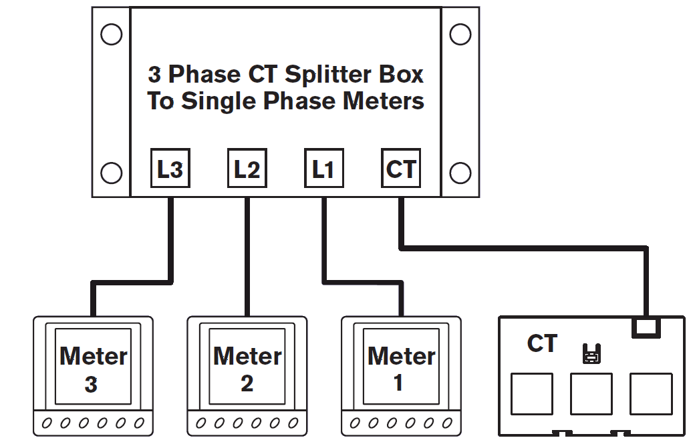
AUTOMATIC / MANUAL MODE DESCRIPTION
Press E key for 3 seconds to toggle between Automatic and Manual mode.
Note: By default unit operates in automatic mode.
In automatic mode online pages scroll automatically at the rate of 5 seconds per page.
In automatic mode when any key is pressed, unit temporarily switches to manual mode and the appropriate page is displayed, also if no key is pressed for 5 seconds the unit will return to automatic.

MODBUS REGISTER ADDRESSES LIST
Readable Parameters : [ Length (Register) : 2 : Data Structure : Float ]
Address | Hex Address | Parameter |  | Address | Hex Address | Parameter |  | Address | Hex Address | Parameter |  | Address | Hex Address | Parameter
30000 | 0x00 | Voltage V1N |  | 30100 | 0x64 | KVArh1 (Import) |  | 30199 | 0xC7 | 30th Harmonic Voltage V1-N |  | 30299 | 0x12B | 20th Harmonic Voltage V3-N
30002 | 0x02 | Voltage V2N |  | 30102 | 0x66 | KVArh2 (Import) |  | 30201 | 0xC9 | 1st Harmonic Voltage V2-N |  | 30301 | 0x12D | 21st Harmonic Voltage V3-N
30004 | 0x04 | Voltage V3N |  | 30104 | 0x68 | KVArh3 (Import) |  | 30203 | 0xCB | 2nd Harmonic Voltage V2-N |  | 30303 | 0x12F | 22nd Harmonic Voltage V3-N
30006 | 0x06 | Average Voltage LN |  | 30106 | 0x6A | KVArh1 (Export) |  | 30205 | 0xCD | 3rd Harmonic Voltage V2-N |  | 30305 | 0x131 | 23rd Harmonic Voltage V3-N
30008 | 0x08 | Voltage V12 |  | 30108 | 0x6C | KVArh2 (Export) |  | 30207 | 0xCF | 4th Harmonic Voltage V2-N |  | 30307 | 0x133 | 24th Harmonic Voltage V3-N
30010 | 0x0A | Voltage V23 |  | 30110 | 0x6E | KVArh3 (Export) |  | 30209 | 0xD1 | 5th Harmonic Voltage V2-N |  | 30309 | 0x135 | 25th Harmonic Voltage V3-N
30012 | 0x0C | Voltage V31 |  | 30112 | 0x70 | Total KVArh (Import) |  | 30211 | 0xD3 | 6th Harmonic Voltage V2-N |  | 30311 | 0x137 | 26th Harmonic Voltage V3-N
30014 | 0x0E | Average Voltage LL |  | 30114 | 0x72 | Total KVArh (Export) |  | 30213 | 0xD5 | 7th Harmonic Voltage V2-N |  | 30313 | 0x139 | 27th Harmonic Voltage V3-N
30016 | 0x10 | Current I1 |  | 30116 | 0x74 | KVAh1 |  | 30215 | 0xD7 | 8th Harmonic Voltage V2-N |  | 30315 | 0x13B | 28th Harmonic Voltage V3-N
30018 | 0x12 | Current I2 |  | 30118 | 0x76 | KVAh2 |  | 30217 | 0xD9 | 9th Harmonic Voltage V2-N |  | 30317 | 0x13D | 29th Harmonic Voltage V3-N
30020 | 0x14 | Current I3 |  | 30120 | 0x78 | KVAh3 |  | 30219 | 0xDB | 10th Harmonic Voltage V2-N |  | 30319 | 0x13F | 30th Harmonic Voltage V3-N
30022 | 0x16 | Average Current |  | 30122 | 0x7A | Neutral Current |  | 30221 | 0xDD | 11th Harmonic Voltage V2-N |  | 30321 | 0x141 | 1st Harmonic Voltage V1-V2
30024 | 0x18 | KW1 |  | 30124 | 0x7C | THD of 1st Phase Voltage |  | 30223 | 0xDF | 12th Harmonic Voltage V2-N |  | 30323 | 0x143 | 2nd Harmonic Voltage V1-V2
30026 | 0x1A | KW2 |  | 30126 | 0x7E | THD of 2nd Phase Voltage |  | 30225 | 0xE1 | 13th Harmonic Voltage V2-N |  | 30325 | 0x145 | 3rd Harmonic Voltage V1-V2
30028 | 0x1C | KW3 |  | 30128 | 0x80 | THD of 3rd Phase Voltage |  | 30227 | 0xE3 | 14th Harmonic Voltage V2-N |  | 30327 | 0x147 | 4th Harmonic Voltage V1-V2
30030 | 0x1E | KVA1 |  | 30130 | 0x82 | THD of Voltage V12 |  | 30229 | 0xE5 | 15th Harmonic Voltage V2-N |  | 30329 | 0x149 | 5th Harmonic Voltage V1-V2
30032 | 0x20 | KVA2 |  | 30132 | 0x84 | THD of Voltage V23 |  | 30231 | 0xE7 | 16th Harmonic Voltage V2-N |  | 30331 | 0x14B | 6th Harmonic Voltage V1-V2
30034 | 0x22 | KVA3 |  | 30134 | 0x86 | THD of Voltage V31 |  | 30233 | 0xE9 | 17th Harmonic Voltage V2-N |  | 30333 | 0x14D | 7th Harmonic Voltage V1-V2
30036 | 0x24 | KVAr1 |  | 30136 | 0x88 | THD of Current I1 |  | 30235 | 0xEB | 18th Harmonic Voltage V2-N |  | 30335 | 0x14F | 8th Harmonic Voltage V1-V2
30038 | 0x26 | KVAr2 |  | 30138 | 0x8A | THD of Current I2 |  | 30237 | 0xED | 19th Harmonic Voltage V2-N |  | 30337 | 0x151 | 9th Harmonic Voltage V1-V2
30040 | 0x28 | KVAr3 |  | 30140 | 0x8C | THD of Current I3 |  | 30239 | 0xEF | 20th Harmonic Voltage V2-N |  | 30339 | 0x153 | 10th Harmonic Voltage V1-V2
30042 | 0x2A | Total KW |  | 30141 | 0x8D | 1st Harmonic Voltage V1-N |  | 30241 | 0xF1 | 21st Harmonic Voltage V2-N |  | 30341 | 0x155 | 11th Harmonic Voltage V1-V2
30044 | 0x2C | Total KVA |  | 30143 | 0x8F | 2nd Harmonic Voltage V1-N |  | 30243 | 0xF3 | 22nd Harmonic Voltage V2-N |  | 30343 | 0x157 | 12th Harmonic Voltage V1-V2
30046 | 0x2E | Total KVAr |  | 30145 | 0x91 | 3rd Harmonic Voltage V1-N |  | 30245 | 0xF5 | 23rd Harmonic Voltage V2-N |  | 30345 | 0x159 | 13th Harmonic Voltage V1-V2
30048 | 0x30 | PF1 |  | 30147 | 0x93 | 4th Harmonic Voltage V1-N |  | 30247 | 0xF7 | 24th Harmonic Voltage V2-N |  | 30347 | 0x15B | 14th Harmonic Voltage V1-V2
30050 | 0x32 | PF2 |  | 30149 | 0x95 | 5th Harmonic Voltage V1-N |  | 30249 | 0xF9 | 25th Harmonic Voltage V2-N |  | 30349 | 0x15D | 15th Harmonic Voltage V1-V2
30052 | 0x34 | PF3 |  | 30151 | 0x97 | 6th Harmonic Voltage V1-N |  | 30251 | 0xFB | 26th Harmonic Voltage V2-N |  | 30351 | 0x15F | 16th Harmonic Voltage V1-V2
30054 | 0x36 | Average PF |  | 30153 | 0x99 | 7th Harmonic Voltage V1-N |  | 30253 | 0xFD | 27th Harmonic Voltage V2-N |  | 30353 | 0x161 | 17th Harmonic Voltage V1-V2
30056 | 0x38 | Frequency |  | 30155 | 0x9B | 8th Harmonic Voltage V1-N |  | 30255 | 0xFF | 28th Harmonic Voltage V2-N |  | 30355 | 0x163 | 18th Harmonic Voltage V1-V2
30058 | 0x3A | Total Net KWh |  | 30157 | 0x9D | 9th Harmonic Voltage V1-N |  | 30257 | 0x101 | 29th Harmonic Voltage V2-N |  | 30357 | 0x165 | 19th Harmonic Voltage V1-V2
30060 | 0x3C | Total Net KVAh |  | 30159 | 0x9F | 10th Harmonic Voltage V1-N |  | 30259 | 0x103 | 30th Harmonic Voltage V2-N |  | 30359 | 0x167 | 20th Harmonic Voltage V1-V2
30062 | 0x3E | Total Net KVArh |  | 30161 | 0xA1 | 11th Harmonic Voltage V1-N |  | 30261 | 0x105 | 1st Harmonic Voltage V3-N |  | 30361 | 0x169 | 21st Harmonic Voltage V1-V2
30064 | 0x40 | KW Max Active Power |  | 30163 | 0xA3 | 12th Harmonic Voltage V1-N |  | 30263 | 0x107 | 2nd Harmonic Voltage V3-N |  | 30363 | 0x16B | 22nd Harmonic Voltage V1-V2
30066 | 0x42 | KW Min Active Power |  | 30165 | 0xA5 | 13th Harmonic Voltage V1-N |  | 30265 | 0x109 | 3rd Harmonic Voltage V3-N |  | 30365 | 0x16D | 23rd Harmonic Voltage V1-V2
30068 | 0x44 | KVAr Max Reactive Power |  | 30167 | 0xA7 | 14th Harmonic Voltage V1-N |  | 30267 | 0x10B | 4thHarmonic Voltage V3-N |  | 30367 | 0x16F | 24th Harmonic Voltage V1-V2
30070 | 0x46 | KVAr Min Reactive Power |  | 30169 | 0xA9 | 15th Harmonic Voltage V1-N |  | 30269 | 0x10D | 5th Harmonic Voltage V3-N |  | 30369 | 0x171 | 25th Harmonic Voltage V1-V2
30072 | 0x48 | KVA Max Apparent Power |  | 30171 | 0xAB | 16th Harmonic Voltage V1-N |  | 30271 | 0x10F | 6th Harmonic Voltage V3-N |  | 30371 | 0x173 | 26th Harmonic Voltage V1-V2
30074 | 0x4A | Max I1 Demand |  | 30173 | 0xAD | 17th Harmonic Voltage V1-N |  | 30273 | 0x111 | 7th Harmonic Voltage V3-N |  | 30373 | 0x175 | 27th Harmonic Voltage V1-V2
30076 | 0x4C | Max I2 Demand |  | 30175 | 0xAF | 18th Harmonic Voltage V1-N |  | 30275 | 0x113 | 8th Harmonic Voltage V3-N |  | 30375 | 0x177 | 28th Harmonic Voltage V1-V2
30078 | 0x4E | Max I3 Demand |  | 30177 | 0xB1 | 19th Harmonic Voltage V1-N |  | 30277 | 0x115 | 9th Harmonic Voltage V3-N |  | 30377 | 0x179 | 29th Harmonic Voltage V1-V2
30080 | 0x50 | Max Average Demand |  | 30179 | 0xB3 | 20th Harmonic Voltage V1-N |  | 30279 | 0x117 | 10th Harmonic Voltage V3-N |  | 30379 | 0x17B | 30th Harmonic Voltage V1-V2
30082 | 0x52 | Hours Run |  | 30181 | 0xB5 | 21st Harmonic Voltage V1-N |  | 30281 | 0x119 | 11th Harmonic Voltage V3-N |  | 30381 | 0x17D | 1st Harmonic Voltage V2-V3
30084 | 0x54 | KWH1 (Import) |  | 30183 | 0xB7 | 22nd Harmonic Voltage V1-N |  | 30283 | 0x11B | 12th Harmonic Voltage V3-N |  | 30383 | 0x17F | 2nd Harmonic Voltage V2-V3
30086 | 0x56 | KWH2 (Import) |  | 30185 | 0xB9 | 23rd Harmonic Voltage V1-N |  | 30285 | 0x11D | 13th Harmonic Voltage V3-N |  | 30385 | 0x181 | 3rd Harmonic Voltage V2-V3
30088 | 0x58 | KWH3 (Import) |  | 30187 | 0xBB | 24th Harmonic Voltage V1-N |  | 30287 | 0x11F | 14th Harmonic Voltage V3-N |  | 30387 | 0x183 | 4th Harmonic Voltage V2-V3
30090 | 0x5A | KWH1 (Export) |  | 30189 | 0xBD | 25th Harmonic Voltage V1-N |  | 30289 | 0x121 | 15th Harmonic Voltage V3-N |  | 30389 | 0x185 | 5th Harmonic Voltage V2-V3
30092 | 0x5C | KWH2 (Export) |  | 30191 | 0xBF | 26th Harmonic Voltage V1-N |  | 30291 | 0X123 | 16th Harmonic Voltage V3-N |  | 30391 | 0x187 | 6th Harmonic Voltage V2-V3
30094 | 0x5E | KWH3 (Export) |  | 30193 | 0xC1 | 27th Harmonic Voltage V1-N |  | 30293 | 0x125 | 17th Harmonic Voltage V3-N |  | 30393 | 0x189 | 7th Harmonic Voltage V2-V3
30096 | 0x60 | Total KWh (Import) |  | 30195 | 0xC3 | 28th Harmonic Voltage V1-N |  | 30295 | 0x127 | 18th Harmonic Voltage V3-N |  | 30395 | 0x18B | 8th Harmonic Voltage V2-V3
30098 | 0x62 | Total KWh (Export) |  | 30197 | 0xC5 | 29th Harmonic Voltage V1-N |  | 30297 | 0x129 | 19th Harmonic Voltage V3-N |  | 30397 | 0x18D | 9th Harmonic Voltage V2-V3

MODBUS REGISTER ADDRESSES LIST
Readable Parameters : [ Length (Register) : 2 : Data Structure : Float ]
Address | Hex Address | Parameter |  | Address | Hex Address | Parameter |  | Address | Hex Address | Parameter |  | Address | Hex Address | Parameter
30399 | 0x18F | 10th Harmonic Voltage V2-V3 |  | 30499 | 0x1F3 | 30th Harmonic Voltage V3-V1 |  | 30599 | 0x257 | 20th Harmonic Current I2 |  | 30716 | 0x2CC | Existing MAX I3 Demand
30401 | 0x191 | 11th Harmonic Voltage V2-V3 |  | 30501 | 0x1F5 | 1st Harmonic Current I1 |  | 30601 | 0x259 | 21st Harmonic Current I2 |  | 30718 | 0x2CE | Existing MAX Average I Demand
30403 | 0x193 | 12th Harmonic Voltage V2-V3 |  | 30503 | 0x1F7 | 2nd Harmonic Current I1 |  | 30603 | 0x25B | 22nd Harmonic Current I2 | APPLICATION OF PULSE OUTPUT  Pulse output from RI-F385-G meter can be interfaced into a process through a PLC for the on-line control of energy content in the process. If the PLC has a self exciting digital input, an external DC voltage supply is not needed.  The KWh pulse is also used to derive average KWh information at the PLC.  # All fuse are : 0.5A Class CC UL type  0.5A fast acting 600Vac  LEFT HAND CT MOUNTING PHASE CORRECTION  The meter phases L1, L2 & L3 are setup as default for the CT to be mounted as an incomer on the RH (Right Hand) side of the board. Meter display shows rH when “I” is pressed for 3 seconds.  When the CT is mounted on the LH (Left Hand) side of the board the phase sequence needs to be reversed.  - Press “I” for 3 seconds, then release and then press again for 3 seconds. Phase will be reversed and the display will show LH.  - Wait 5 seconds for the meter to resume online reading. Meter display shows LH when “I” is pressed for 3 seconds.
30405 | 0x195 | 13th Harmonic Voltage V2-V3 |  | 30505 | 0x1F9 | 3rd Harmonic Current I1 |  | 30605 | 0x25D | 23rd Harmonic Current I2
30407 | 0x197 | 14th Harmonic Voltage V2-V3 |  | 30507 | 0x1FB | 4th Harmonic Current I1 |  | 30607 | 0x25F | 24th Harmonic Current I2
30409 | 0x199 | 15th Harmonic Voltage V2-V3 |  | 30509 | 0x1FD | 5th Harmonic Current I1 |  | 30609 | 0x261 | 25th Harmonic Current I2
30411 | 0x19B | 16th Harmonic Voltage V2-V3 |  | 30511 | 0x1FF | 6th Harmonic Current I1 |  | 30611 | 0x263 | 26th Harmonic Current I2
30413 | 0x19D | 17th Harmonic Voltage V2-V3 |  | 30513 | 0x201 | 7th Harmonic Current I1 |  | 30613 | 0x265 | 27th Harmonic Current I2
30415 | 0x19F | 18th Harmonic Voltage V2-V3 |  | 30515 | 0x203 | 8th Harmonic Current I1 |  | 30615 | 0x267 | 28th Harmonic Current I2
30417 | 0x1A1 | 19th Harmonic Voltage V2-V3 |  | 30517 | 0x205 | 9th Harmonic Current I1 |  | 30617 | 0x269 | 29th Harmonic Current I2
30419 | 0x1A3 | 20th Harmonic Voltage V2-V3 |  | 30519 | 0x207 | 10th Harmonic Current I1 |  | 30619 | 0x26B | 30th Harmonic Current I2
30421 | 0x1A5 | 21st Harmonic Voltage V2-V3 |  | 30521 | 0x209 | 11th Harmonic Current I1 |  | 30621 | 0x26D | 1st Harmonic Current I3
30423 | 0x1A7 | 22nd Harmonic Voltage V2-V3 |  | 30523 | 0x20B | 12th Harmonic Current I1 |  | 30623 | 0x26F | 2nd Harmonic Current I3
30425 | 0x1A9 | 23rd Harmonic Voltage V2-V3 |  | 30525 | 0x20D | 13th Harmonic Current I1 |  | 30625 | 0x271 | 3rd Harmonic Current I3
30427 | 0x1AB | 24th Harmonic Voltage V2-V3 |  | 30527 | 0x20F | 14th Harmonic Current I1 |  | 30627 | 0x273 | 4th Harmonic Current I3
30429 | 0x1AD | 25th Harmonic Voltage V2-V3 |  | 30529 | 0x211 | 15th Harmonic Current I1 |  | 30629 | 0x275 | 5th Harmonic Current I3
30431 | 0x1AF | 26th Harmonic Voltage V2-V3 |  | 30531 | 0x231 | 16th Harmonic Current I1 |  | 30631 | 0x277 | 6th Harmonic Current I3
30433 | 0x1B1 | 27th Harmonic Voltage V2-V3 |  | 30533 | 0x215 | 17th Harmonic Current I1 |  | 30633 | 0x279 | 7th Harmonic Current I3
30435 | 0x1B3 | 28th Harmonic Voltage V2-V3 |  | 30535 | 0x217 | 18th Harmonic Current I1 |  | 30635 | 0x27B | 8th Harmonic Current I3
30437 | 0x1B5 | 29th Harmonic Voltage V2-V3 |  | 30537 | 0x219 | 19th Harmonic Current I1 |  | 30637 | 0x27D | 9th Harmonic Current I3
30439 | 0x1B7 | 30th Harmonic Voltage V2-V3 |  | 30539 | 0x21B | 20th Harmonic Current I1 |  | 30639 | 0x27F | 10th Harmonic Current I3
30441 | 0x1B9 | 1st Harmonic Voltage V3-V1 |  | 30541 | 0x21D | 21st Harmonic Current I1 |  | 30641 | 0x281 | 11th Harmonic Current I3
30443 | 0x1BB | 2nd Harmonic Voltage V3-V1 |  | 30543 | 0x21F | 22nd Harmonic Current I1 |  | 30643 | 0x283 | 12th Harmonic Current I3
30445 | 0x1BD | 3rd Harmonic Voltage V3-V1 |  | 30545 | 0x221 | 23rd Harmonic Current I1 |  | 30645 | 0x285 | 13th Harmonic Current I3
30447 | 0x1BF | 4th Harmonic Voltage V3-V1 |  | 30547 | 0x223 | 24th Harmonic Current I1 |  | 30647 | 0x287 | 14th Harmonic Current I3
30449 | 0x1C1 | 5th Harmonic Voltage V3-V1 |  | 30549 | 0x225 | 25th Harmonic Current I1 |  | 30649 | 0x289 | 15th Harmonic Current I3
30451 | 0x1C3 | 6th Harmonic Voltage V3-V1 |  | 30551 | 0x227 | 26th Harmonic Current I1 |  | 30651 | 0x28B | 16th Harmonic Current I3
30453 | 0x1C5 | 7th Harmonic Voltage V3-V1 |  | 30553 | 0x229 | 27th Harmonic Current I1 |  | 30653 | 0x28D | 17th Harmonic Current I3
30455 | 0x1C7 | 8th Harmonic Voltage V3-V1 |  | 30555 | 0x22B | 28th Harmonic Current I1 |  | 30655 | 0x28F | 18th Harmonic Current I3
30457 | 0x1C9 | 9th Harmonic Voltage V3-V1 |  | 30557 | 0x22D | 29th Harmonic Current I1 |  | 30657 | 0x291 | 19th Harmonic Current I3
30459 | 0x1CB | 10th Harmonic Voltage V3-V1 |  | 30559 | 0x22F | 30th Harmonic Current I1 |  | 30659 | 0x293 | 20th Harmonic Current I3
30461 | 0x1CD | 11th Harmonic Voltage V3-V1 |  | 30561 | 0x231 | 1st Harmonic Current I2 |  | 30661 | 0x295 | 21st Harmonic Current I3
30463 | 0x1CF | 12th Harmonic Voltage V3-V1 |  | 30563 | 0x233 | 2nd Harmonic Current I2 |  | 30663 | 0x297 | 22nd Harmonic Current I3
30465 | 0x1D1 | 13th Harmonic Voltage V3-V1 |  | 30565 | 0x235 | 3rd Harmonic Current I2 |  | 30665 | 0x299 | 23rd Harmonic Current I3
30467 | 0x1D3 | 14th Harmonic Voltage V3-V1 |  | 30567 | 0x237 | 4th Harmonic Current I2 |  | 30667 | 0x29B | 24th Harmonic Current I3
30469 | 0x1D5 | 15th Harmonic Voltage V3-V1 |  | 30569 | 0x239 | 5th Harmonic Current I2 |  | 30669 | 0x29D | 25th Harmonic Current I3
30471 | 0x1D7 | 16th Harmonic Voltage V3-V1 |  | 30571 | 0x23B | 6th Harmonic Current I2 |  | 30671 | 0x29F | 26th Harmonic Current I3
30473 | 0x1D9 | 17th Harmonic Voltage V3-V1 |  | 30573 | 0x23D | 7th Harmonic Current I2 |  | 30673 | 0x2A1 | 27th Harmonic Current I3
30475 | 0x1DB | 18th Harmonic Voltage V3-V1 |  | 30575 | 0x23F | 8th Harmonic Current I2 |  | 30675 | 0x2A3 | 28th Harmonic Current I3
30477 | 0x1DD | 19th Harmonic Voltage V3-V1 |  | 30577 | 0x241 | 9th Harmonic Current I2 |  | 30677 | 0x2A5 | 29th Harmonic Current I3
30479 | 0x1DF | 20th Harmonic Voltage V3-V1 |  | 30579 | 0x243 | 10th Harmonic Current I2 |  | 30679 | 0x2A7 | 30th Harmonic Current I3
30481 | 0x1E1 | 21st Harmonic Voltage V3-V1 |  | 30581 | 0x245 | 11th Harmonic Current I2 |  | 30684 | 0x2AC | Serial No (Data Structure : Hex)
30483 | 0x1E3 | 22nd Harmonic Voltage V3-V1 |  | 30583 | 0x247 | 12th Harmonic Current I2 |  | 30700 | 0x2BC | Phase Sequence Indication
30485 | 0x1E5 | 23rd Harmonic Voltage V3-V1 |  | 30585 | 0x249 | 13th Harmonic Current I2 |  | 30702 | 0x2BE | Existing KW MAX Active Power
30487 | 0x1E7 | 24th Harmonic Voltage V3-V1 |  | 30587 | 0x24B | 14th Harmonic Current I2 |  | 30704 | 0x2C0 | Existing KW MIN Active Power
30489 | 0x1E9 | 25th Harmonic Voltage V3-V1 |  | 30589 | 0x24D | 15th Harmonic Current I2 |  | 30706 | 0x2C2 | Existing KVAr MAX Reactive Power
30491 | 0x1EB | 26th Harmonic Voltage V3-V1 |  | 30591 | 0x24F | 16th Harmonic Current I2 |  | 30708 | 0x2C4 | Existing KVAr MIN Reactive Power
30493 | 0x1ED | 27th Harmonic Voltage V3-V1 |  | 30593 | 0x251 | 17th Harmonic Current I2 |  | 30710 | 0x2C6 | Existing KVA MAX Apparent Power
30495 | 0x1EF | 28th Harmonic Voltage V3-V1 |  | 30595 | 0x253 | 18th Harmonic Current I2 |  | 30712 | 0x2C8 | Existing MAX I1 Demand
30497 | 0x1F1 | 29th Harmonic Voltage V3-V1 |  | 30597 | 0x255 | 19th Harmonic Current I2 |  | 30714 | 0x2CA | Existing MAX I2 Demand
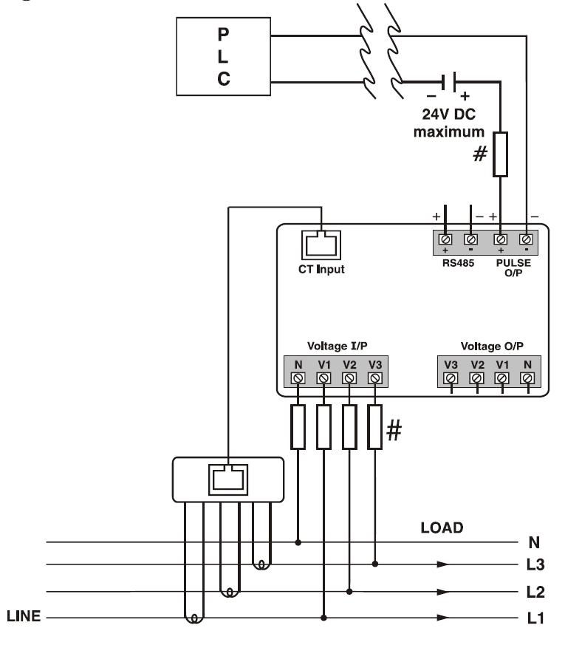

MODBUS REGISTER ADDRESSES LIST
Readable / Writable Parameters : [ Data Structure : Integer ]
Address | Hex Address | Parameter | Range |  | Length (Register) |  | Address | Hex Address | Parameter | Range |  | Length (Register)
 |  |  | Min Value | Max Value |  |  | 40024 | 0x18 | Page Address Sequence | 1-21 | 1-First Page : 21-Last Page | 1
40000 | 0x00 | Password | 0 | 9998 | 1 |  | 40025 | 0x19 | Page Address Sequence | 1-21 | 1-First Page : 21-Last Page | 1
 |  |  | Value | Meaning |  |  | 40026 | 0x1A | Page Address Sequence | 1-21 | 1-First Page : 21-Last Page | 1
40001 | 0x01 | Network Selection | 0x0000 | 3P4W | 1 |  | 40027 | 0x1B | Page Address Sequence | 1-21 | 1-First Page : 21-Last Page | 1
 |  |  | 0x0002 | 1P2W-P1 | 1 |  | 40028 | 0x1C | Page Address Sequence | 1-21 | 1-First Page : 21-Last Page | 1
 |  |  | 0x0003 | 1P2W-P2 | 1 |  | 40028 | 0x1D | Page Address Sequence | 1-21 | 1-First Page : 21-Last Page | 1
 |  |  | 0x0004 | 1P2W-P3 | 1 |  | 40030 | 0x1E | Page Address Sequence | 1-21 | 1-First Page : 21-Last Page | 1
 |  |  | Min Value | Max Value |  |  | 40031 | 0x1F | Page Address Sequence | 1-21 | 1-First Page : 21-Last Page | 1
40002 | 0x02 | CT Secondary (Readable Only) | 5 | 5 | 1 |  | 40032 | 0x20 | Page Address Sequence | 1-21 | 1-First Page : 21-Last Page | 1
40003 | 0x03 | CT Primary | 5 | 10000 | 1 |  | 40033 | 0x21 | Page Address Sequence | 1-21 | 1-First Page : 21-Last Page | 1
40004 | 0x04 | PT Secondary | 173 | 415 | 1 |  | 40054 | 0x36 | Page Address Sequence | 1-21 | 1-First Page : 21-Last Page | 1
40005 | 0x05 | PT Primary | 100 | 500000 | 2 |  | 40055 | 0x37 | Page Address Sequence | 1-21 | 1-First Page : 21-Last Page | 1
40007 | 0x07 | Slave ID | 1 | 255 | 1 |  | 40059 | 0x3B | Page Address Sequence | 1-21 | 1-First Page : 21-Last Page | 1
 |  |  | Value | Meaning |  |  | 40060 | 0x3C | Page Address Sequence | 1-21 | 1-First Page : 21-Last Page | 1
40008 | 0x08 | Baud Rate | 0x0000 | 300 bps | 1 |  |  |  |  | Value | Meaning
 |  |  | 0x0001 | 600 bps | 1 |  | 40034 | 0x22 | Demand Interval Method | 0x0000 | Sliding | 1
 |  |  | 0x0002 | 1200 bps | 1 |  |  |  |  | 0x0001 | Fixed | 1
 |  |  | 0x0003 | 2400 bps | 1 |  | 40035 | 0x23 | Demand Interval Duration | Min 1 | Max 30 | 1
 |  |  | 0x0004 | 4800 bps | 1 |  | 40036 | 0x24 | Demand interval Length | Min 1 | Max 30 | 1
 |  |  | 0x0005 | 9600 bps | 1 |  | 40043 | 0x2B | Reset Max | 1 | Reset All Max Power | 1
 |  |  | 0x0006 | 19200 bps | 1 |  | 40044 | 0x2C | Reset Energy | 1 | Reset All Energy To Factory Setting Range | 1
40009 | 0x09 | Parity | 0x0000 | None | 1
 |  |  |  |  |  |  | 40045 | 0x2D Reset | Reset Hours Run | 1 | Reset Hours Run | 1
 |  |  | 0x0001 | Odd | 1
 |  |  |  |  |  |  |  |  |  | Min Value | Max Value
 |  |  | 0x0002 | Even | 1
 |  |  |  |  |  |  | 40057 | 0x39 | Pulse Duration | 0.1(second) | 2.0(seconds) | 1
40010 | 0x0A | Stop Bit | 0x0000 | 1 | 1
 |  |  |  |  |  |  | 40058 | 0x3A | Pulse Weight | 00.10 | 99.99 | 1
 |  |  | 0x000 | 2 | 1
 |  |  |  |  |  |  |  |  |  | Value | Meaning
 |  |  | Min Value | Max Value
 |  |  |  |  |  |  | 40063 | 0x3F | Reset Max Current | 1 | Reset Max Current | 1
40011 | 0x0B | Backlight OFF | 0 | 7200 | 1
40012 | 0x0C | Factory Default Reset | 1 | Set to factory setting range | 1
40016 | 0x10 | Auto Mode Pages | 1 | 21
 |  |  | Page No | Meaning
40017 | 0x11 | Page Address Sequence | 1-21 | 1-First Page : 21-Last Page | 1
40018 | 0x12 | Page Address Sequence | 1-21 | 1-First Page : 21-Last Page | 1
40019 | 0x13 | Page Address Sequence | 1-21 | 1-First Page : 21-Last Page | 1
40020 | 0x14 | Page Address Sequence | 1-21 | 1-First Page : 21-Last Page | 1
40021 | 0x15 | Page Address Sequence | 1-21 | 1-First Page : 21-Last Page | 1
40022 | 0x16 | Page Address Sequence | 1-21 | 1-First Page : 21-Last Page | 1
40023 | 0x17 | Page Address Sequence | 1-21 | 1-First Page : 21-Last Page | 1

Specifications subject to change as development is a continuous process

RAYLEIGH INSTRUMENTS LIMITED
Cutlers Road South Woodham Ferrers
Chelmsford CM3 5WA UK

